Solution to every third end-of-chapter problem
Basics of Engineering Economy, 2nd edition
Leland Blank and Anthony Tarquin

Chapter 4
Present Worth Analysis

4.1 The do-nothing alternative is not an option (1) when it is absolutely required that one of the defined alternatives be selected (such as for legal purposes), and (2) when each alternative has only cost cash flow estimates.

4.4 (a) A, B and C are mutually exclusive; D and E are independent.

(b) X is in all bundles as the mutually exclusive selection. The two independent
projects have 2² = 4 bundles. The 4 viable options are:

X only XD XE XDE

4.7 PW _{solar} = -14,000 - 1500(P/A,10%,4) + 0.25(14,000)(P/F,10%,4)
= -14,000 - 1500(3.1699) + 3500(0.6830)
= $-16,364

PW _{line} = -12,000 - 600(P/A,10%,4)
= -12,000 - 600(3.1699)
= $-13,902
Install power line; its cost is lower.

4.10 PW_{manual} = -425,000 – [90,000(P/A,8%,5) + 7000(P/G,8%5)] + 80,000(P/F,8%,5)
= -425,000 – [90,000(3.9927) + 7000(7.3724)] + 80,000(0.6806)
= $-781,502

PW_{robotic} = -850,000 –[10,000(P/A,8%,5) + 1000(P/G,8%5)] + 300,000(P/F,8%,5)
= -850,000 – [10,000(3.9927) + 1000(7.3724)] + 300,000(0.6806)
= $-693,119
Select the robotic system

4.13 Interest rate of 12% per year compounded monthly is 1% per month.

PW = -950 + 70(P/A,1%,36)
= -950 + 70(30.1075)
= $+1157.53
Since PW > 0, the service is financially justified

4.16 (a) PW_{A} = -70,000 – 20,000(P/A,12%,3) + 15,000(P/F,12%,3)
= -70,000 – 20,000(2.4018) + 15,000(0.7118)
= $-107,359

PW_{B} = -140,000 – 8,000(P/A,12%,3) + 40,000(P/F,12%,3)
= -140,000 – 8,000(2.4018) + 40,000(0.7118)
= $-130,742

Select method A

(b) A: Function is –PV(12,3,-20000,15000) – 70000 PW = $-107,360
B: Function is –PV(12,3,-8000,40000) – 140000 PW = $-130,743

4.19 (a) Monetary units are in $1000. Calculate PW values to select the pull system.

PW_{pull} = -1500 – 700(P/A,10%,8) + 100(P/F,10%,8)
= -1500 – 700(5.3349) + 100(0.4665)
= $-5187.780 ($-5,187,780)

PW_{push} = -2250 – 600(P/A,10%,8) + 50(P/F,10%,8) – 500(P/F,10%,3)
= -2250 – 600(5.3349) + 50(0.4665) – 500(0.7513)
= $-5803.265 ($-5,803,265)

(b) By spreadsheet, enter the following into single cells to display the PW values.

PW_{pull} : = - PV(10%,8,-700000,100000)-1500000
PW_{push} : = - PV(10%,8,-600000,50000)-2250000-PV(10%,3,,-500000)

4.22 (a) For Allison (A), use i = 1% per month and n = 60 months to calculate PW.

PW_{A} = -40,000 - 5000(P/A,1%,60) + 10,000(P/F,1%,60)
= -40,000 - 5000(44.9550) + 10,000(0.5504)
= $-259,271

For Joshua (J), use effective semiannual i and n = 10 to calculate PW.

effective i = (1.01)⁶ -1 = 6.152%

PW_{J} = -60,000 – 13,000(P/A,6.152%,10) + 8,000(P/F,6.152%,10)
= -60,000 – 13,000(7.30737) + 8,000(0.55045)
= $-150,592

Select Joshua’s plan

(b) A spreadsheet solution follows; select Joshua’s plan

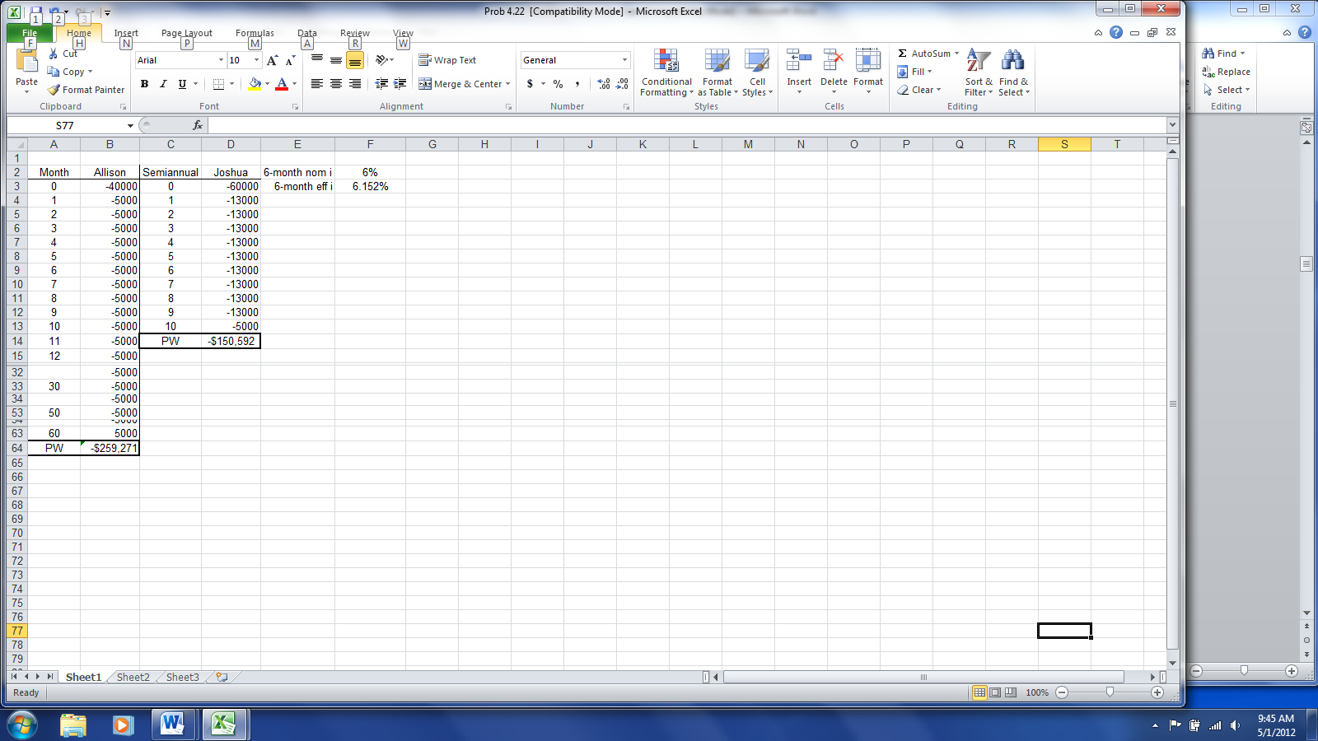

4.25 (a) Semiannual bond dividend is 1000(0.05)/2 = $25 per 6 months.
Semiannual interest rate is 5%/2 = 2.5%.

PW = -925 + 25(P/A,2.5%,16) + 800(P/F,2.5%,16)
= -925 + 25(13.0550) + 800(0.6736)
= $-59.74

No, the bond investment did not make the target rate since PW < 0.

(b) A spreadsheet solution follows to obtain PW = $-59.72

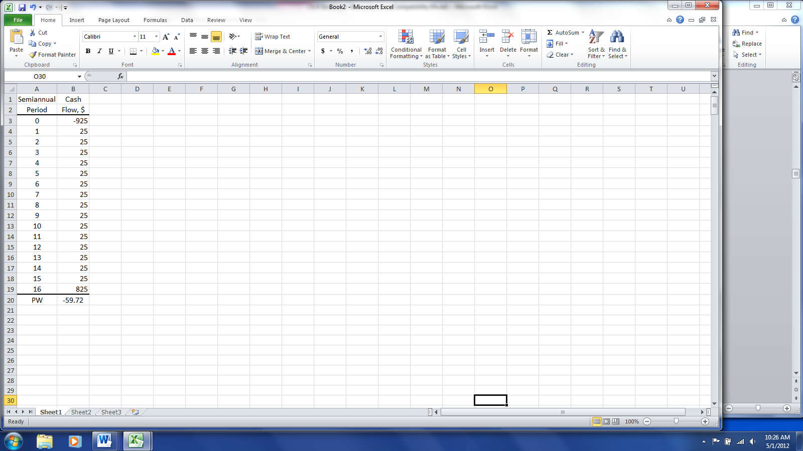

4.28 Semiannual bond dividend is 10,000(0.05)/2 = $250 per 6 months.
Semiannual interest rate expected is 6%/2 = 3%.

PW = -9000 + 250(P/A,3%,40) + 10,000(P/F,3%,40)
= -9000 + 250(23.1148) + 10,000(0.3066)
= $-155

No, the bond investment does not make the target rate since PW < 0.

A spreadsheet solution follows.

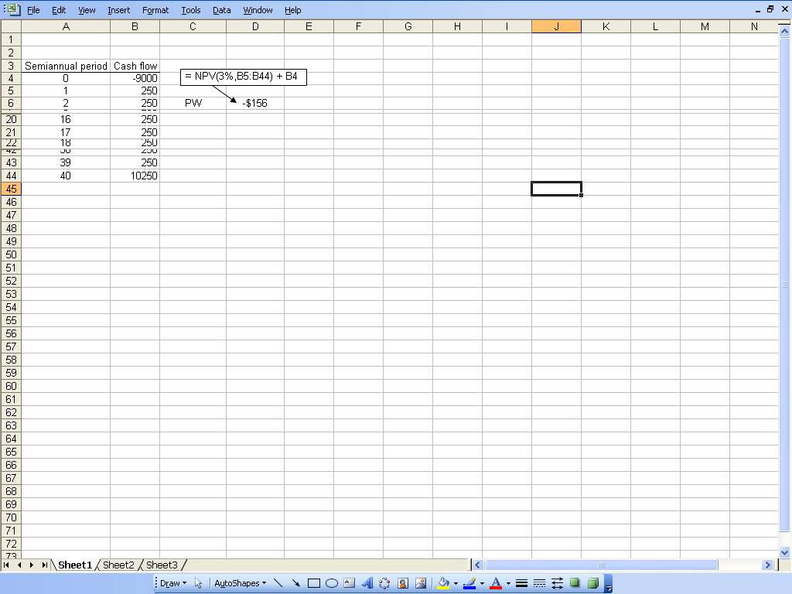

4.31 LCM is 48 months; repurchase P after 24 months

PW_{P} = -13,650 - 200(P/A,1%,48) - 13,650(P/F,1%,24)
= -13,650 - 200(37.9740) - 13,650(0.7876)
= $-31,996

PW_{F} = -22,900 - 50(P/A,1%,48) + 2000(P/F,1%,48)
= -22,900 - 50(37.9740) + 2000(0.6203)
= $-23,558

Select the fiber optic sensors

4.34 (a) LCM is 4 years; repurchased CFRP after 2 years

PW_{CFRP} = -205,000 – 29,000(P/A,10%,4) – 203,000(P/F,10%,2)
+ 2000(P/F,10%,4)
= -205,000 – 29,000(3.1699) – 203,000(0.8264) + 2000(0.6830)
= $-463,320

PW_{FRC} = -235,000 – 27,000(P/A,10%,4) + 20,000(P/F,10%,4)
= -235,000 – 27,000(3.1699) + 20,000(0.6830)
= $-306,927

Select material FRC

(b) PW_{CFRP} function: = - 205000 - PV(10%,4,-29000,2000)+ PV(10%,2,,203000)

PW_{FRC} function: = - 235000 - PV(10%,4,-27000,20000)

4.37 (a) PW_{C} = -375,000 -200(P/A,8%,13)(P/F,8%,7)
= -375,000 – 200(7.9038)(0.5835)
= $-375,922

For asphalt, repave after 10 years and re-start maintenance charge in year 12.

PW_{A} = -250,000[1+(P/F,8%,10)] – 2500(P/A,8%,9)[(P/F,8%,1)+(P/F,8%,11)]
= -250,000[1.4632] – 2500(6.2469)[0.9259 + 0.4289]
= $-386,958

Select the concrete option with a marginal advantage.

(b) Maintenance costs are incurred over 5 years only; there are none for concrete. Now, select the asphalt option by a large margin.

PW_{C} = $-375,000

PW_{A} = -250,000 – 2500(P/A,8%,4)(P/F,8%,1)
= -250,000 – 2500(3.3121)(0.9259)
= $-257,667

A spreadsheet solution for parts (a) and (b) follows.

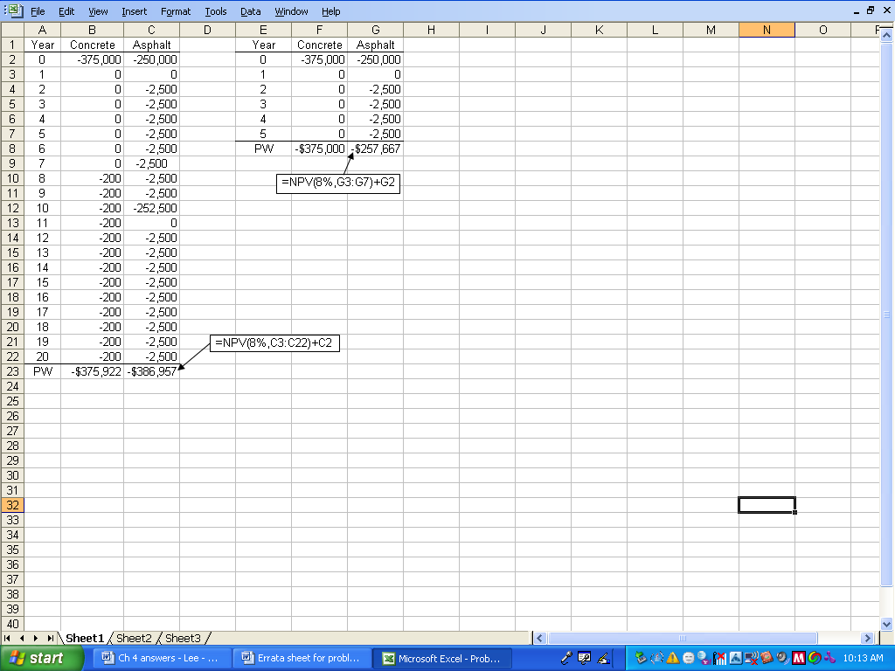

4.40 FW_{C} = -80,000[(F/P,12%,15)+(F/P,12%,10)+(F/P,12%,5)+1]
= -80,000[5.4736 + 3.1058 + 1.7623 + 1]
= $-907,336

FW_{M} = -200,000(F/P,12%,15) – 500[(F/P,12%,12)+(F/P,12%,9)+(F/P,12%,6)
+(F/P,12%,3)+1] +25,000
= -200,000(5.4736) - 500[3.8969 + 2.7731 + 1.9738 + 1.4049 + 1] + 25,000
= $-1,075,244

Select the concrete exterior by a future worth amount of approximately $168,000.

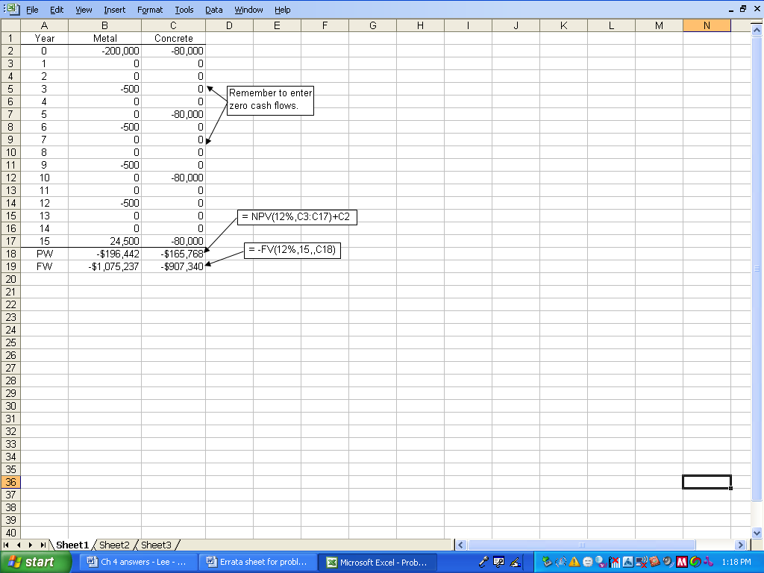

4.43 LCC_{A} = -750,000 – (6000 + 2000)(P/A,0.5%,240) – 150,000[(P/F,0.5%,60)
+ (P/F,0.5%,120) + (P/F,0.5%,180)]
= -750,000 – (8000)(139.5808) – 150,000[(0.7414) + (0.5496) + (0.4075)]
= $-2,121,421

LCC_{B} = -1.1 – (3000 + 1000)(P/A,0.5%,240)
= -1.1 – (4000)(139.5808)
= $-1,658,323

Select proposal B.

4.46 CC = - [38(120,000) + 17(150,000)]/0.08
= $-88,875,000

4.49 CC = -1,700,000 – 350,000(A/F,6%,3)/0.06
= - 1,700,000 – 350,000(0.31411)/0.06
= $-3,532,308

4.52 CC = 100,000 + 100,000/0.08
= $1,350,000

4.55 Monetary terms are in $1000 units.

CC = -200 - 300(P/F,8%,4) - 50(A/F,8%,5)/0.08 - (8/0.08)(P/F,8%,14)
= -200 - 300(0.7350) - 50(0.17046)/0.08 - (8/0.08)(0.3405)
= $-561.088 ($-561,088)

4.58 Quarterly interest rate is 12/4 = 3% with 4 quarters per year

CC = AW/i; select alternative E. Monetary values are in $1000 units.

CC_{E} = [-2000(A/P,3%,16) + 300 + 50(A/F,3%,16)]/0.03
= [-2000(0.07961) + 300 + 50(0.04961)]/0.03
= $+4775.35 ($+4,775,350)

CC_{F} = [-3000(A/P,3%,32) + 100 + 70(A/F,3%,32)]/0.03
= [-3000(0.04905) + 100 + 70(0.01905)]/0.03
= $-1527.217 ($-1,527,217)

CC_{G} = -10,000 + 400/0.03
= $+3333.333 ($+3,333,333)

By spreadsheet, enter the following into single cells to display the CC values
Answer: Select alternative E.

E: = (-PMT(3%,16,-2000000,50000)+300000)/0.03 Display: $+4,775,295
F: = (-PMT(3%,32,-3000000,70000)+100000)/0.03 Display: $-1,526,886
G: = -10000000+400000/0.03 Display: $+3,333,333

4.61 Budget = $800,000 i = 10% 6 viable bundles

Bundle Projects NCF_{j0} NCF_{jt} S PW at 10%

1 X $-250,000 $ 50,000 $ 45,000 $-60,770
2 Y -300,000 90,000 -10,000 -21,539
3 Z -550,000 150,000 100,000 -6,215
4 XY -550,000 140,000 35,000 -82,309
5 XZ -800,000 200,000 145,000 -66,985
6 Do nothing 0 0 0 0

PW_{j} = NCF_{j}(P/A,10%,4) + S(P/F,10%,4) - NCF_{j0}

Since no bundle has PW > 0. Select ‘Do nothing’ project.

4.64 P = -35,000 - 20,000(P/A,10%,4) - 25,000(P/F,10%,2) + 10,000(P/F,10%,4)
= -35,000 - 20,000(3.1699) - 25,000(0.8264) + 10,000(0.6830)
= $-112,228
Answer is (d)

4.67 CC = A/i

A = 10,000(A/F,10%,5)
= 10,000(0.16380)
= $-1638

CC = -1638/0.10
= $-16,380

Answer is (b)

4.70 Answer is (d)

